**Project Initialization and Planning Phase**

| Date | 20 june 2024 |
| --- | --- |
| Team ID | 739849 |
| Project Name | Doctors Annual Salary Prediction |
| Maximum Marks | 3 Marks |

**Define Problem Statements (Customer Problem Statement Template):**

This project proposal aims to solve a specific problem with a clear objective, defined scope, and concise problem statement. It details the approach, key features, and necessary resources, including hardware, software, and personnel, to implement the solution effectively.

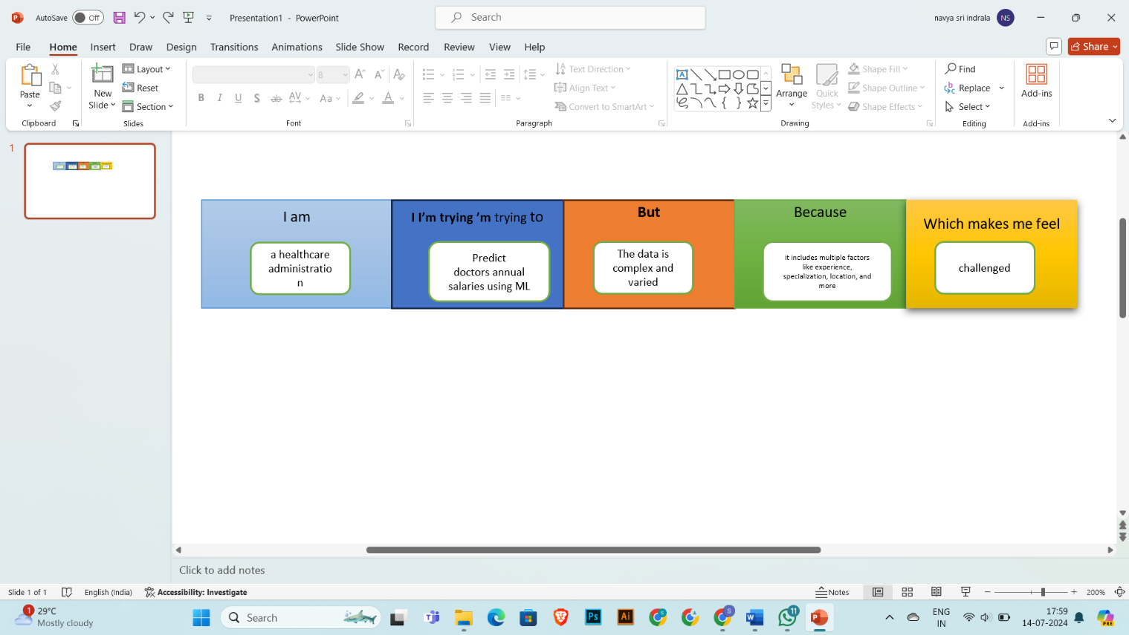

|  |  |  |  |  |  |
| --- | --- | --- | --- | --- | --- |
| **Problem**  **Statement (PS)** | **I am**  **(Customer)** | **I’m trying to** | **But** | **Because** | **Which makes me feel** |
| PS-1 | a healthcare administrator | predict doctors' annual salaries using ML | the data is complex and varied | it includes multiple factors like experience, specialization, location, and more | challenged |
| PS-2 | a healthcare recruiter | forecast salary trends | there is no standardized data | different hospitals and clinics have varying pay scales | uncertain |